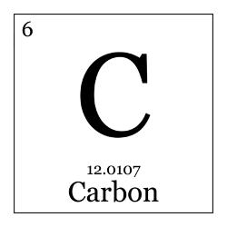
hemistry 2017 “Education is the most powerful
Ms. weapon which you can use to change
isneros the world.” –Nelson Mandela

River City High School | E-mail: ccisneros@wusd.k12.ca.us | Telephone: ext. 2703

Welcome Raiders! During this semester, you will be able to not only comprehend matter and energy at a molecular level, but also how chemistry plays a part in your every day lives. In this course, you will explore the study of chemistry through various demonstrations, lecture activities, and hands-on laboratories both independently and collaboratively. This is a demanding course, so please be sure to use my support, your colleagues’ support, and be willing to engage in the curriculum to make this a successful experience. This course fulfills the laboratory science requirement and prerequisite for admission to California State Universities and the University of California.

Course goals:
- Students will understand the broad meaning of Chemistry and how processes around us relate to one another.
- Students will build and expand on skills such as: studying, organizing, inquiring, critical thinking, speaking, and scientific writing.

Recommended Materials: Optional Supportive materials:
- Composition Notebook 1. Post-it notes
- Writing Devices: Pencils 2. Index cards
- Highlighter (any color)
- Scientific Calculator (A phone calculator MAY NOT BE USED)

Grading:
Notebook | 20% | Includes class work, notes and homework
Projects | 20% | Includes Lab work, group projects and individual projects
Quizzes | 40% | Given weekly
Tests | 20% | Benchmark Tests/Final (given at the end of each unit)

Units:
- Combustion 4. Chemical Reactions
- Heat and Energy in the Earth System 5. Carbon Dioxide and Climate Change
- Atoms and Elements 6. The Dynamics of Chemistry

Grading Scale:
90% to 100% = A
80% to 89% = B
70% to 79% = C

Classroom Rules:
- ALL RCHS rules must be followed.
- Come PREPARED to class each day: bring your pens, pencils, notebook, and paper.
- No food or beverage consumption in the lab areas.
- The bell does not dismiss you.
- Be in the room before the tardy bell rings or you will be marked tardy.
- NO electronics to be used in class unless instructed to do so. Electronics will be taken away and other measures will be taken. If I see it, I take it!
- Backpacks and purses are to remain off the desks at all times.
- Classroom agreements must be followed.
- Laboratory contract must be signed and followed.
If any of the above rules are broken, further consequences will be taken such as: call home, seat change, etc.
Absences:
If you are absent, it is your responsibility to complete all the make-up work:
- Assignment worksheets are placed in the classroom, you are welcome to collect them before or after class.
- Make-up for missed quizzes and tests will be given before school or during lunch the day the student returns. Please discuss lab make-ups with Ms. C. AFTER ONE WEEK: MAX 50% of points.
Late-work:
Once an assignment is not turned-in on time, each day decreases the maximum point value the student can receive by 10%.

One day late = Max 90% Three days late = Max 70% WEEKENDS
Two days late = Max 80% Four days late = Max 60% ARE
Three days late = Max 70% After five days, Max 50% INCLUDED!

NOTEBOOKS WILL NOT BE COLLECTED FOR NOTEBOOK CHECK PAST 1 week of the due date!
Homework Reminder Sign-up (for students and guardians/parents):
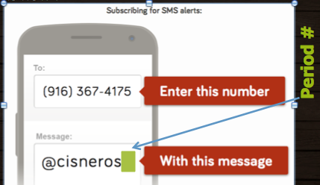
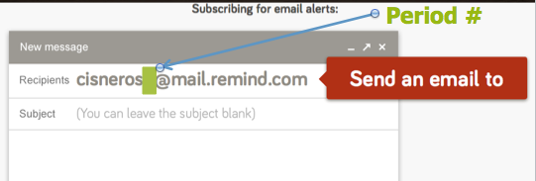

81010

Keep in mind….

I believe that each and every one of you has the capacity to succeed and strive in this course. I am here for you before & after school as well as lunch time for any support you may need. Please let me know as soon as possible if you need any accommodations.
I’ll see you all on back to school night
-Ms. Cisneros
Student Print: ____________________________________________________________

Parent/Guardian Signature:__________________________________________________

